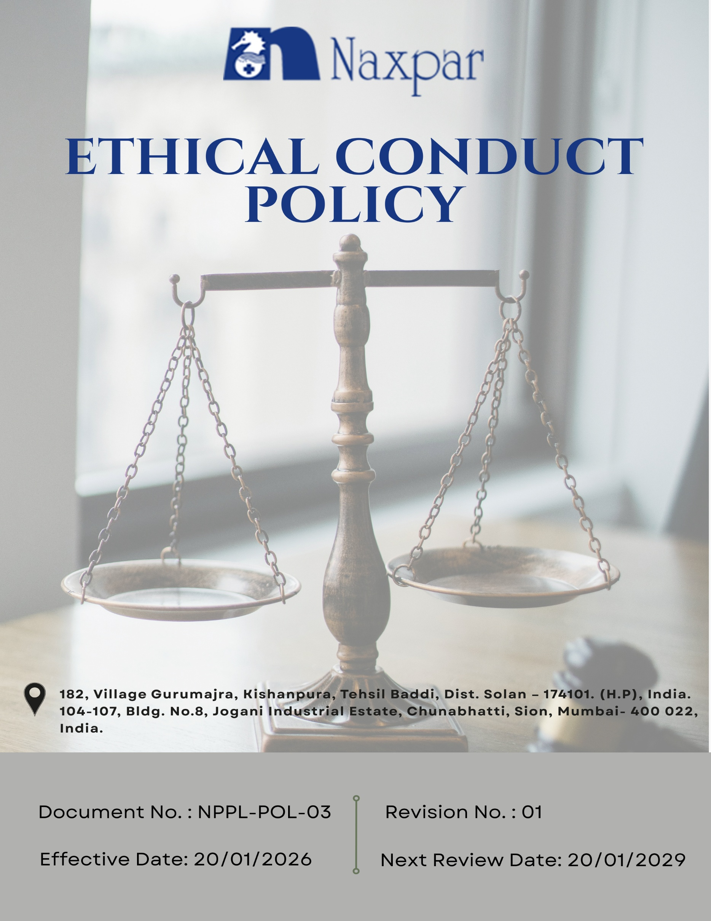

Contents

Preface 3
Policy Declaration 3
Scope 4
Key Focus Areas 4
Qualitative Objectives 5
Quantitative Targets 6
Alignment with the United Nations Sustainable Development Goals (SDGs) 8
Examples and Guidance 8
Continuous Improvement 10
Addressing Policy Violations 11
Responsibilities 11
Review Mechanism 12
Employee Acknowledgment Form 13

Preface
Naxpar Pharma Pvt. Ltd. is committed to conducting all its business activities with the highest standards of ethical conduct, integrity, and professionalism. As a manufacturer and exporter of pharmaceutical formulations, cosmetics, herbal, and nutraceutical products, the Company recognizes that ethical behaviour is essential to building trust with employees, customers, business partners, regulators, and the communities in which it operates. Naxpar Pharma Pvt. Ltd. conducts its operations in compliance with applicable laws and regulations and in line with principles of honesty, fairness, transparency, and accountability.

The Company adopts a strict zero-tolerance approach toward bribery, corruption, fraud, conflicts of interest, and any form of unethical or improper conduct. All employees, directors, and business partners are expected to act responsibly, use sound judgment, safeguard company assets and confidential information, and promptly report any actual or suspected ethical or legal concerns. This Ethical Conduct Policy serves as the foundation for ethical decision-making at Naxpar Pharma Pvt. Ltd. and reinforces the Company’s commitment to responsible, compliant, and sustainable business practices across all operations.

Policy Declaration
Naxpar Pharma Pvt. Ltd. affirms its commitment to fostering a culture rooted in ethical values and responsible conduct. The Company expects all directors, employees, and business partners to act with integrity, fairness, and respect in every business interaction. Ethical behaviour, transparency, and compliance with applicable laws and internal standards are fundamental to how Naxpar Pharma Pvt. Ltd. conducts its business. The Company encourages the good-faith reporting of concerns and ensures appropriate protection to those who raise them. This declaration serves as a guiding statement for ethical conduct across the organization.

Scope
This Ethical Conduct Policy applies to all employees, consultants, and business partners of Naxpar Pharma Pvt. Ltd. and governs conduct across all functions and operations, including manufacturing, quality assurance, supply chain activities, sales, and customer engagement. It also extends to interactions with vendors, suppliers, service providers, and other external stakeholders, ensuring that all business relationships are conducted in line with the Company’s values of integrity, transparency, and ethical responsibility.

Sr. No. | Company Name | Location | Address Details
1 | Naxpar Pharma Pvt. Ltd. | Head Office | 104-107, Bldg. No.8, Jogani Industrial Estate, Chunabhatti, Sion, Mumbai- 400 022, India.
2 |  | Plant | 182, Village Gurumajra, Kishanpura, Tehsil Baddi, Dist. Solan – 174101. (H.P), India.

Key Focus Areas
- Anti-Corruption: Prevent bribery, and all corrupt practices through clear standards, training, and enforcement.
- Conflict of Interest: Require disclosure and management of personal or financial interests that may influence business decisions.
- Fraud Prevention: Strengthen internal controls and monitoring to identify and prevent fraud, supported by confidential reporting mechanisms.
- Anti-Money Laundering (AML): Comply with AML requirements by monitoring relevant transactions, detecting suspicious activity, and equipping employees with necessary training.
- Information Security: Protect confidential and sensitive data through access controls, cybersecurity measures, and employee awareness programs.
- Use of Company Assets: Ensure all company assets are used responsibly, efficiently, and only for business purposes.

Qualitative Objectives
- Anti-Corruption
- Promote awareness of anti-corruption principles through targeted training and communication
- Ensure consistent enforcement of anti-corruption rules across all business units and locations.
- Encourage reporting of corruption related incidents through confidential channels.

- Conflict of Interest
- Implement clear procedures for identifying, disclosing, and managing potential conflicts of interest fairly and impartially.
- Ensure all business decisions are objective, unbiased, and free from personal or financial influence.
- Maintain transparency in dealings with suppliers, clients, and partners by documenting conflicts and mitigation actions.

- Fraud Prevention
- Maintain a zero-tolerance stance toward fraud, misrepresentation, or any form of dishonest conduct.
- Implement internal controls, audits, and monitoring mechanisms to detect and prevent fraud.
- Encourage timely reporting of fraud or irregularities through confidential reporting systems.
- Investigate all reported incidents promptly and take corrective or disciplinary action as needed.

- Anti-Money Laundering (AML)
- Comply with all relevant AML laws, regulations, and internal procedures to prevent misuse of company operations.
- Ensure employees are aware of AML obligations, including monitoring transactions and recognizing warning signs.
- Maintain accurate records of transactions to support transparency and regulatory adherence.

- Information Security
- Protect confidential business, employee, and customer information through robust access controls and cyber security measures.
- Continuously assess and strengthen data protection practices to address evolving risks and regulatory requirements and thereby ensure secure handling, storage, and disposal of physical and digital information.
- Restrict access to sensitive information based on role and need-to-know principles.
- Promote employee awareness of information security responsibilities through regular training.

- Use of Company Assets
- Educate employees on proper use and protection of company assets, equipment, and resources.
- Encourage employees to report any suspected misuse or damage promptly.

Quantitative Targets
FY 2022–23 has been designated as the reference year for all ethical governance objectives at Naxpar Pharma Pvt. Ltd., including business integrity, anti-corruption, conflict of interest management, fraud prevention, and anti-money laundering. Progress will be evaluated against this baseline to drive continuous improvement, with the aim of achieving the established targets by FY 2029–30.

- Anti-Corruption
- Ensure that 100% of supplier and business partner agreements incorporate anti-bribery and anti-corruption clauses by FY 2029–30.
- Deliver annual anti-corruption and ethics training to 100% of employees in procurement, finance, and senior management through FY 2029–30.
- Maintain zero cases of incidents related to bribery or corruption annually

- Conflict of Interest
- Achieve 100% completion of Conflict-of-Interest declarations by all managers, board members and employees by FY 2029–30.
- Track and resolve 100% of disclosed conflicts within 60 days of reporting.

- Fraud Prevention
- Maintain zero confirmed fraud incidents across all operations annually.
- Ensure 100% of employees and contractors are informed of, and have ongoing access to, confidential reporting channels by FY 2029–30.
- Strengthen and review fraud detection mechanisms and internal controls to cover 100% of business processes by FY 2029–30.

- Anti-Money Laundering (AML)
- Provide AML training to 100% of finance, compliance, procurement, and sales personnel by FY 2029–30.
- Implement transaction monitoring and suspicious activity detection mechanisms across 100% of operations by FY 2029–30.
- Maintain confidential AML reporting channels that are accessible to 100% of employees.

- Information Security
- Ensure 100% encryption of sensitive and confidential data at rest and in transit across all critical IT systems, applications, and communication channels by FY 2029–30.
- Ensure 100% of employees complete annual information security and phising awareness training by FY 2029–30 and on an annual basis thereafter.
- Implement continuous monitoring to detect security vulnerabilities and cyber threats across 100% of critical IT systems by FY 2029–30.

- Use of Company Assets
- Maintain 100% inventory accuracy for fixed assets till FY 2029–30.
- Ensure 100% of employees handling sensitive assets receive annual training on proper use by FY 2029–30.

Alignment with the United Nations Sustainable Development Goals (SDGs)
The sustainability objectives and performance targets align with the following Sustainable Development Goals (SDGs):
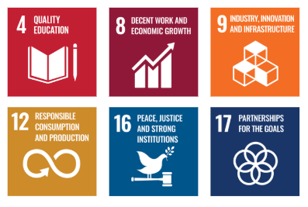

Examples and Guidance
To ensure consistent understanding and implementation of this Ethical Conduct Policy, the following examples and guidance illustrate expected behavior and practical actions for employees:

- Anti-Corruption
- Example: A supplier offers an employee a cash bonus or expensive gift to secure a contract.
- Guidance: The employee must refuse the offer and report it immediately through confidential channels. Employees must ensure all business decisions are based on merit, compliance, and company policy, maintaining transparency, fairness, and integrity.
- Conflict of Interest
- Example: A manager owns shares in a company bidding for a supply contract and participates in the selection process.
- Guidance: The team lead must disclose the relationship and step aside from the selection process. All potential conflicts must be reported, and decisions must remain objective and free from personal bias.
- Fraud Prevention
- Example: An employee falsifies an invoice or expense report to claim unauthorized payments.
- Guidance: Employees must adhere to internal controls, segregation of duties, and approval processes. Suspected fraud must be reported through confidential channels. Participation in annual fraud risk assessments and training is mandatory.
- Anti-Money Laundering (AML)
- Example: A client attempts to make a payment from an unverified or suspicious source, structured to avoid reporting thresholds.
- Guidance: Employees must monitor all high-risk transactions and escalate suspicious activities promptly through designated channels. Complete AML training and remain aware of applicable regulations. Use confidential reporting mechanisms for concerns.
- Information Security
- Example: Employee shares login credentials with a third party or clicks on a phishing email, compromising company data.
- Guidance: Employees must follow IT security policies, access controls, and encryption standards. Attend regular security training, report incidents immediately, and avoid unsafe digital practices to safeguard confidential information.
6. Use of Company Assets
- Example: An employee uses company laptops, vehicles, or equipment for personal business without approval, or damages property through negligence.
- Guidance: Employees must use company assets responsibly and solely for legitimate business purposes. Maintain accurate records, report misuse or damage promptly, and participate in annual training on proper handling of company resources.

Continuous Improvement
Naxpar Pharma Pvt. Ltd. is committed to continuously strengthening ethical conduct to remain aligned with evolving regulations, industry standards, and emerging operational risks. The Company fosters a culture of integrity, ensuring transparency, accountability, and compliance with all applicable legal and regulatory requirements.
- Continuous Training & Awareness: All employees undergo regular training on anti-corruption, conflict of interest, fraud prevention, anti-money laundering (AML), information security, and responsible use of company assets to reinforce ethical behavior and standards.
- Risk Evaluation & Independent Reviews: Regular internal risk assessments and independent audits are conducted to identify ethical, operational, financial, and cybersecurity risks, evaluate controls, and implement corrective actions as necessary.
- Collaborative Compliance Initiatives: Naxpar Pharma actively participates in industry forums and engages with regulatory bodies to stay updated on laws, governance guidelines, and best practices.
- Enhanced Monitoring & Reporting Systems: Secure systems support oversight of transactions, fraud detection, data protection, and confidential reporting, enabling prompt investigation and resolution of issues.
- Culture of Transparency & Feedback: Open and accessible channels encourage employees, suppliers, and stakeholders to raise concerns, report unethical conduct, or provide suggestions without fear of retaliation, promoting continuous improvement in ethical standards.

Addressing Policy Violations
Naxpar Pharma Pvt. Ltd. maintains a zero-tolerance approach to breaches of its Ethical Conduct Policy. All suspected or confirmed violations are handled seriously, fairly, and promptly to uphold the Company’s commitment to integrity, transparency, and accountability.
- Reporting Violations: Employees, contractors, and business partners are encouraged to report any unethical, illegal, or suspicious conduct through appropriate channels, including the Human Resources or Compliance teams, or the Company’s confidential whistleblower system. Reports may be submitted anonymously, and all concerns are handled without fear of retaliation.
- Investigation Process: Reported concerns are reviewed and investigated promptly by designated internal authorities or, when necessary. Investigations are impartial and confidential, with information shared strictly on a need-to-know basis. Whistleblower identities are protected unless disclosure is required by law.
- Corrective Actions: If a violation is confirmed, Naxpar Pharma Pvt. Ltd. will take corrective and disciplinary action proportional to the severity of the breach. Actions may include counseling, formal warnings, retraining, suspension, reassignment, termination, or, where necessary, reporting to regulatory authorities and initiating legal proceedings.
- Protection from Retaliation: Retaliation against any individual who reports concerns in good faith or participates in an investigation is strictly prohibited. Any retaliatory act is treated as a serious violation and will result in disciplinary action.

Responsibilities
At Naxpar Pharma Pvt. Ltd., upholding ethical conduct is a shared responsibility across all levels of the organization. Specific roles include:
- Compliance Officer: Ensure compliance with all ethical policies, advise on ethical dilemmas, and oversee reporting systems and whistleblower mechanisms.
- HR Manager: Administer employee training on ethics, anti-corruption, and conflict-of-interest policies, and manage grievance reporting and resolution processes.
- IT Manager: Safeguard company and customer data through secure systems, access controls, and regular cybersecurity awareness programs.
- Internal Audit Team: Conduct audits to assess policy compliance, identify risks, and recommend corrective actions for any gaps or violations.
- Senior Management: Allocate resources for ethical governance, and promote a culture of integrity, transparency, and accountability.

Review Mechanism
The Ethical Conduct Policy is reviewed once in every three years or earlier if required by the Compliance Officer to ensure its continued relevance, effectiveness, and alignment with legal and regulatory requirements. Updates may be made based on audit findings, changes in applicable laws, employee feedback, or evolving business practices. Any revisions are communicated to all employees, and necessary training is provided to ensure awareness and compliance.
Effective Date | : 20.01.2026
Next Review Date | : 20.01.2029
Revision No. | : 01

Approved By:

Employee Acknowledgment Form
I acknowledge that I have received, read, and understood the Ethical Conduct Policy of Naxpar Pharma Pvt. Ltd. to uphold the principles set forth in the policy, including preventing bribery and corruption, identifying and disclosing conflicts of interest, preventing fraud, complying with anti-money laundering regulations, and protecting confidential company and client information.
I understand that it is my duty to follow this policy in all professional conduct and to report any suspected violations or unethical behavior through the company’s confidential whistleblower system or other designated channels. I am aware that any breach of this policy may result in appropriate disciplinary action agree as per company guidelines.
By signing this declaration, I confirm my personal commitment to maintaining ethical behavior, accountability, and transparency in all my responsibilities at Naxpar Pharma Pvt. Ltd.

Employee Name | : _________________________
Employee ID | : _________________________
Department | : _________________________
Signature | : _________________________

